**Marginal Distribution**:

The marginal distribution of a variable is the distribution of that variable alone, without considering any other variables. It’s obtained by summing or integrating over the other variables in the dataset.

For example, in a two-way table showing the relationship between age and income, the marginal distribution of age would be the total counts or proportions for each age group, regardless of income.

**Conditional Distribution:**

The conditional distribution of a variable is the distribution of that variable given that another variable has a specific value. It shows the probability or frequency of one variable under the condition that another variable is held fixed.

Using the same example, the conditional distribution of income given that age is 30 would show the distribution of income only for those who are 30 years old.

**Examples:**

|  |  |  |  |  |
| --- | --- | --- | --- | --- |
| **Gender** | **Coffee** | **Tea** | **Water** | **Total** |
| **Male** | 40 | 30 | 20 | 90 |
| **Female** | 30 | 50 | 30 | 110 |
| **Total** | 70 | 80 | 50 | 200 |

### Marginal Distribution:

* **Marginal Distribution of Gender**: This shows the distribution of gender alone:
  + Male: 90 out of 200 (45%)
  + Female: 110 out of 200 (55%)
* **Marginal Distribution of Beverage Preference**: This shows the distribution of beverage preference alone:
  + Coffee: 70 out of 200 (35%)
  + Tea: 80 out of 200 (40%)
  + Water: 50 out of 200 (25%)

**Conditional Distribution:**

* **Conditional Distribution of Beverage Preference given Gender**:
  + For **Males** (Total = 90):
    - Coffee: 40 out of 90 (44.4%)
    - Tea: 30 out of 90 (33.3%)
    - Water: 20 out of 90 (22.2%)
  + For **Females** (Total = 110):
    - Coffee: 30 out of 110 (27.3%)
    - Tea: 50 out of 110 (45.5%)
    - Water: 30 out of 110 (27.3%)
* **Conditional Distribution of Gender given Beverage Preference**:
  + For **Coffee drinkers** (Total = 70):
    - Male: 40 out of 70 (57.1%)
    - Female: 30 out of 70 (42.9%)
  + For **Tea drinkers** (Total = 80):
    - Male: 30 out of 80 (37.5%)
    - Female: 50 out of 80 (62.5%)
  + For **Water drinkers** (Total = 50):
    - Male: 20 out of 50 (40%)
    - Female: 30 out of 50 (60%)

These examples illustrate how you can extract marginal and conditional distributions from a two-way table, helping to understand the relationships between different variables.

**1. Dot plots:**

* **Description**: A dot plot is a simple way to visualize the distribution of a small dataset. Each data point is represented by a dot, and identical values are stacked vertically.
* **When to Use**: Best for small datasets, discrete data, or when you want to see the frequency of individual values.
* **Example**: Below is an example of a dot plot used to present the heights of the toddlers at Mrs. Bell’s day-care. Let us describe one dot, representing one toddler.

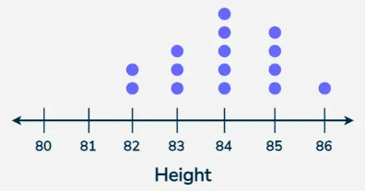

### 2. ****Histograms****:

* **Description**: A histogram displays the distribution of continuous or large sets of data by dividing the data into bins (intervals) and showing the frequency of data points in each bin as bars.
* **When to Use**: Ideal for continuous data or large datasets, and for showing the shape, spread, and skewness of the data distribution.
* **Example:** Uncle Bruno owns a garden with 30 black cherry trees. Each tree is of a different height. The height of the trees (in inches): 61, 63, 64, 66, 68, 69, 71, 71.5, 72, 72.5, 73, 73.5, 74, 74.5, 76, 76.2, 76.5, 77, 77.5, 78, 78.5, 79, 79.2, 80, 81, 82, 83, 84, 85, 87.

|  |  |
| --- | --- |
| Height Range (ft) | Number of Trees (Frequency) |
| 60 - 75 | 3 |
| 66 - 70 | 3 |
| 71 - 75 | 8 |
| 76 - 80 | 10 |
| 81 - 85 | 5 |
| 86 - 90 | 1 |

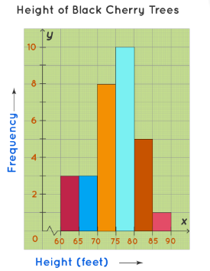

### 3. ****Stem-and-Leaf Plots****:

* **Description**: A stem-and-leaf plot is similar to a histogram but retains the original data values. The "stem" represents the leading digits, and the "leaf" represents the trailing digits.
* **When to Use**: Useful for small to moderately large datasets where you want to display data distribution while retaining actual data values.
* **Example**: Consider the dataset: {23, 25, 27, 31, 34, 35, 41, 43}.
* The stem-and-leaf plot would be

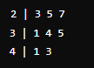

**4. Box Plots:**

A **box plot** (or box-and-whisker plot) is a standardized way of displaying the distribution of data based on five summary statistics: minimum, first quartile (Q1), median (Q2), third quartile (Q3), and maximum. It also highlights outliers.

### Key Components of a Box Plot:

* **Minimum**: The smallest data point, excluding outliers.
* **First Quartile (Q1)**: The median of the lower half of the dataset (25th percentile).
* **Median (Q2)**: The middle value of the dataset (50th percentile).
* **Third Quartile (Q3)**: The median of the upper half of the dataset (75th percentile).
* **Maximum**: The largest data point, excluding outliers.
* **Interquartile Range (IQR)**: The range between the first and third quartiles (Q3 - Q1).
* **Whiskers**: Lines extending from the box to the minimum and maximum values within 1.5 * IQR from Q1 and Q3, respectively.
* **Outliers**: Data points that lie outside 1.5 * IQR from the quartiles, shown as individual points.

### Let's plot a box plot for the same dataset:

data = [3, 3, 4, 5, 7, 7, 7, 8, 10, 12, 12, 15, 17, 18, 18, 20]

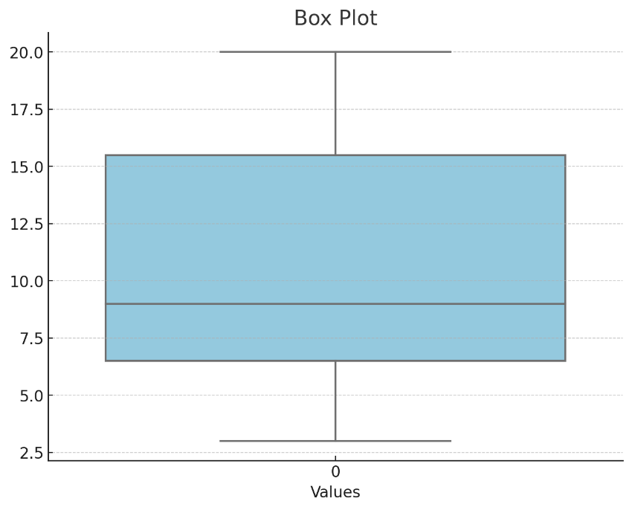

Here is the box plot for the dataset:

* The box shows the interquartile range (IQR), with the bottom edge representing the first quartile (Q1) and the top edge representing the third quartile (Q3).
* The line inside the box represents the median (Q2) of the dataset.
* The "whiskers" extend to the minimum and maximum values within 1.5 times the IQR from Q1 and Q3, respectively.
* Any points outside these whiskers are considered outliers, though in this dataset, there are no outliers.

Box plots are useful for identifying the central tendency, spread, and potential outliers in the data. ​

**Measures of Central Tendency**

**Mean, median, and mode** are measures of central tendency used in statistics to describe the centre of a data distribution.

**1. Mean:**

* **Definition**: The mean is the average of a dataset. It's calculated by summing all the values in the dataset and dividing by the number of values.

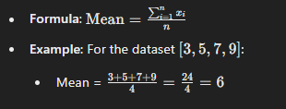

**2. Median:**

* **Definition**: The median is the middle value in a dataset when it is ordered from smallest to largest. If the dataset has an even number of values, the median is the average of the two middle values.
* **Steps**:
  1. Order the data.
  2. If the number of observations is odd, the median is the middle value.
  3. If the number of observations is even, the median is the average of the two middle values.



**3. Mode:**

* **Definition**: The mode is the value that occurs most frequently in a dataset. A dataset may have one mode (unimodal), more than one mode (bimodal or multimodal), or no mode at all if all values are unique.



**Comparison:**

* **Mean** is sensitive to outliers; a single very high or very low value can skew the mean.
* **Median** is robust to outliers; it represents the middle of the data and is not affected by extreme values.
* **Mode** is useful for identifying the most common value in a dataset, especially for categorical data.

**Application:**

* **Mean** is often used when you want to calculate an average.
* **Median** is preferred when the data is skewed or contains outliers.
* **Mode** is most useful with categorical data or when the most common value is of interest.

These measures help summarize and provide insights into the distribution of data.

**Inter Quartile Range:**

The **Interquartile Range (IQR)** is a measure of statistical dispersion, which represents the range within which the central 50% of the data lies. It is calculated as the difference between the third quartile (Q3) and the first quartile (Q1).

**Key Points:**

* **First Quartile (Q1)**: This is the median of the lower half of the dataset (25th percentile).
* **Third Quartile (Q3)**: This is the median of the upper half of the dataset (75th percentile).
* **Interquartile Range (IQR)**: It measures the spread of the middle 50% of the data.
  + **Formula**: IQR=Q3−Q1

**Steps to Calculate IQR:**

1. **Order the Data**: Arrange the dataset in ascending order.
2. **Find Q1**: Identify the first quartile, which is the median of the lower half of the data.
3. **Find Q3**: Identify the third quartile, which is the median of the upper half of the data.
4. **Calculate IQR**: Subtract Q1 from Q3 to find the IQR.

**Example Calculation:**

Consider the dataset: [3,7,8,5,12,14,21,13,18]

1. **Order the Data**: [3,5,7,8,12,13,14,18,21]
2. **Find the Median**: The median (Q2) is 12.
3. **Find Q1**: The lower half is [3,5,7,8] and the median of this is Q1=6 (average of 5 and 7).
4. **Find Q3**: The upper half is [13,14,18,21]and the median of this is Q3=16 (average of 14 and 18).
5. **Calculate IQR**: IQR=Q3−Q1=16−6=10

**Usage:**

* The IQR is used to identify outliers. Any data point that lies below Q1−1.5×IQR or above Q3+1.5×IQR is typically considered an outlier.
* It is a robust measure of spread because it is not affected by extreme values or outliers, making it useful for skewed distributions.

The IQR provides a clear sense of where the bulk of your data lies and is commonly used alongside other measures like the median.

**Measures of Dispersion**

**1. Range:**

* **Definition**: The range is the simplest measure of dispersion. It is the difference between the maximum and minimum values in a dataset.
* **Formula**: Range=Maximum Value−Minimum Value
* **Example**: For the dataset [3,7,8,5,12,14,21,13,18]
  + Range = 21−3=18

**2. Variance:**

* **Definition**: Variance measures the average squared deviation of each data point from the mean. It quantifies how spread out the data points are around the mean.

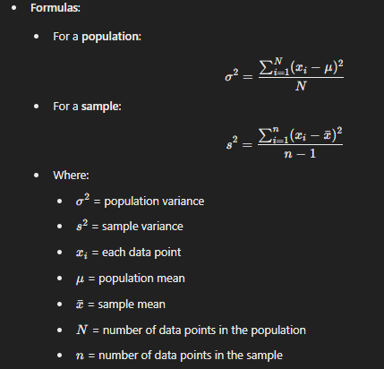

**Example**: Consider the sample dataset [4,8,6,5,3,4,4,7]

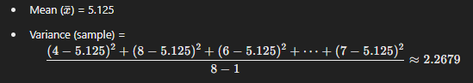

**Why n−1?**: The n−1 term is used instead of n to correct the bias in the estimation of the population variance from a sample. This correction is known as Bessel's correction.

**3. Standard Deviation:**

* **Definition**: Standard deviation is the square root of the variance. It gives a measure of how spread out the numbers are in a dataset and is in the same unit as the data.
* **Formulas**:
* 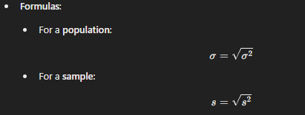

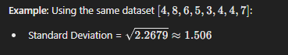

**Key Differences:**

* **Range** gives a quick sense of the spread but is affected by outliers.
* **Variance** and **standard deviation** give a more detailed understanding of the spread by considering how each data point relates to the mean.
* **Standard deviation** is easier to interpret than variance because it is in the same units as the original data.

These measures are essential in statistics to understand the variability in data, and each has its applications depending on the context of the analysis.

**Note: When there are outliers Median is better for central tendency and IQR is better for measuring dispersion.**

**Outliers’ detection:**

Outliers are data points that lie significantly outside the range of the majority of the data. The **Interquartile Range (IQR)** method is commonly used to detect outliers. Here's how you can identify outliers using IQR:

**Steps to Identify Outliers Using IQR:**

1. **Calculate the IQR**:
   * First, find the first quartile (Q1) and third quartile (Q3) of the dataset.
   * Calculate the IQR using the formula: IQR=Q3−Q1
2. **Determine the Outlier Boundaries**:
   * Outliers are typically considered any data points that fall below the lower bound or above the upper bound.
   * **Lower Bound**: Lower Bound=Q1−1.5×IQR
   * **Upper Bound**: Upper Bound=Q3+1.5×IQR
3. **Identify Outliers**:
   * Any data point less than the lower bound or greater than the upper bound is considered an outlier.

**Example:**

Consider the dataset: [3,7,8,5,12,14,21,13,18]

1. **Order the Data**: [3,5,7,8,12,13,14,18,21]
2. **Calculate Q1 and Q3**:
   * Q1 (25th percentile) = 7
   * Q3 (75th percentile) = 14
3. **Calculate IQR**: IQR=14−7=7
4. **Determine the Outlier Boundaries**:
   * Lower Bound = 7−1.5×7=7−10.5=−3.5
   * Upper Bound = 14+1.5×7=14+10.5=24.5
5. **Identify Outliers**:
   * Any data point less than -3.5 or greater than 24.5 is an outlier.
   * In this dataset, there are no outliers because all data points fall within this range.

**Summary:**

Using the IQR method, you can systematically detect outliers in your data, which helps in understanding the distribution and potential anomalies in your dataset.

**Mean Absolute Deviation (MAD)**

It is a measure of the average absolute deviations of data points from the mean of the dataset. It gives you an idea of how spread out the data points are around the mean, without considering the direction (positive or negative).

**Steps to Calculate MAD:**

1. **Find the Mean**:
   * Calculate the mean
2. **Calculate Absolute Deviations**:
   * For each data point, calculate the absolute deviation from the mean
3. **Find the Mean of the Absolute Deviations**:
   * Calculate the average of all the absolute deviations.

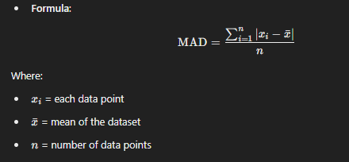

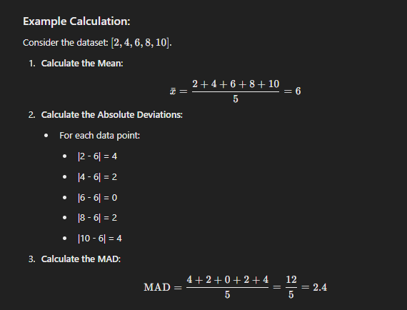

**Interpretation:**

* The MAD value of 2.4 indicates that, on average, each data point in this dataset deviates from the mean by 2.4 units.

**Summary:**

MAD is a simple and robust measure of variability, as it is less affected by outliers than variance and standard deviation. It's useful for understanding the typical distance between data points and the mean in a dataset.

**Z-Score:**

**Z-scores** (also known as standard scores) measure how many standard deviations a data point is from the mean of the dataset. Z-scores allow you to compare data points from different distributions and identify how unusual or typical a data point is within its distribution.

### Formula for Z-Score:

### 

Where:

* z = z-score
* x = individual data point
* μ = mean of the dataset
* σ = standard deviation of the dataset

**Interpretation:**

* **z=0**: The data point is exactly at the mean.
* **z>0**: The data point is above the mean.
* **z<0**: The data point is below the mean.
* **z=1**: The data point is 1 standard deviation above the mean.
* **z=−2**: The data point is 2 standard deviations below the mean.
* **Large positive or negative z-scores**: These indicate that the data point is far from the mean and could be an outlier.

**Using Z-Scores:**

* **Comparing Data Points**: Z-scores standardize different datasets, making it possible to compare scores from different distributions.
* **Identifying Outliers**: Data points with z-scores beyond ±2 or ±3 are often considered potential outliers.
* **Normal Distribution**: In a standard normal distribution, 68% of the data falls within ±1 z-score, 95% within ±2 z-scores, and 99.7% within ±3 z-scores.

**Summary:**

Z-scores are a valuable tool for understanding how a specific data point relates to the rest of the data, enabling you to assess the relative standing of observations within a dataset.

**Normal Distribution**

The **normal distribution**, also known as the Gaussian distribution, is a continuous probability distribution that is symmetric around its mean. It is one of the most important distributions in statistics and is often used because many natural phenomena follow a distribution that is approximately normal.

**Key Characteristics of the Normal Distribution:**

1. **Bell-Shaped Curve**:
   * The normal distribution has a characteristic bell-shaped curve, where most of the data points are concentrated around the mean, tapering off symmetrically on both sides.
2. **Mean, Median, and Mode**:
   * In a perfectly normal distribution, the mean, median, and mode are all equal and located at the center of the distribution.
3. **Symmetry**:
   * The distribution is symmetric about the mean, meaning that the left side is a mirror image of the right side.
4. **Asymptotic**:
   * The tails of the normal distribution curve approach the horizontal axis but never actually touch it.
5. **Empirical Rule (68-95-99.7 Rule)**:
   * Approximately 68% of the data falls within one standard deviation of the mean.
   * About 95% falls within two standard deviations of the mean.
   * About 99.7% falls within three standard deviations of the mean.

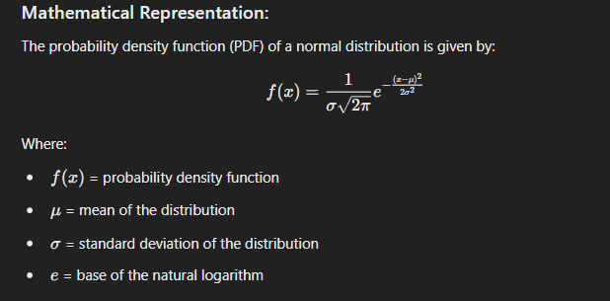

### Standard Normal Distribution:

The standard normal distribution is a special case of the normal distribution where the mean is 0 and the standard deviation is 1. Any normal distribution can be converted to the standard normal distribution using the z-score formula:

**Scatter Plots:**

A **scatter plot** is a type of data visualization that displays the relationship between two numerical variables. Each point on the scatter plot represents an observation from the dataset, with its position determined by the values of the two variables.

**Key Components of a Scatter Plot:**

1. **Axes**:
   * The **x-axis** represents the independent variable (also called the predictor or explanatory variable).
   * The **y-axis** represents the dependent variable (also called the response variable).
2. **Points**:
   * Each point on the scatter plot represents a single observation in the dataset, with its position determined by the values of the two variables.

**Uses of Scatter Plots:**

* **Identifying Relationships**:
  + Scatter plots are used to visually identify the relationship between two variables, such as:
    - **Positive Correlation**: As the x variable increases, the y variable also increases.
    - **Negative Correlation**: As the x variable increases, the y variable decreases.
    - **No Correlation**: The points do not show any clear pattern.
* **Identifying Trends**:
  + Scatter plots can reveal trends in the data, like linear relationships, clusters, or outliers.
* **Identifying Outliers**:
  + Points that are far away from the other points on the scatter plot may be outliers, indicating unusual observations.

**Interpretation:**

* **Linear Relationship**: If the points form a straight line, there is a linear relationship between the variables.
* **Curved Relationship**: If the points form a curve, there is a non-linear relationship.
* **Clusters**: Points that form distinct groups or clusters may indicate subgroups within the data.
* **Outliers**: Points that are far from the rest of the data may be outliers.

**Correlation Coefficient:**

The **correlation coefficient** is a statistical measure that describes the strength and direction of the relationship between two numerical variables. It quantifies how closely two variables are related and is often denoted by **r** when referring to Pearson's correlation coefficient.

**Key Points about the Correlation Coefficient:**

1. **Range**:
   * The correlation coefficient r ranges from **-1** to **1**.
   * **r=1:** Perfect positive correlation. As one variable increases, the other variable increases in a perfectly linear fashion.
   * **r=−1**: Perfect negative correlation. As one variable increases, the other variable decreases in a perfectly linear fashion.
   * **r=0**: No correlation. There is no linear relationship between the variables.
2. **Direction**:
   * A positive r value indicates a positive relationship: as one variable increases, the other variable also increases.
   * A negative r value indicates a negative relationship: as one variable increases, the other variable decreases.
3. **Strength**:
   * The closer r is to 1 or -1, the stronger the linear relationship between the variables.
   * The closer r is to 0, the weaker the linear relationship.

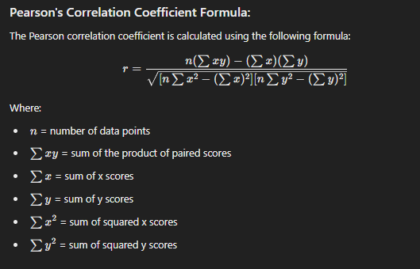

**Interpretation of Correlation Coefficient Values:**

* **0.9 to 1.0** (or -0.9 to -1.0): Very strong positive (or negative) correlation.
* **0.7 to 0.9** (or -0.7 to -0.9): Strong positive (or negative) correlation.
* **0.5 to 0.7** (or -0.5 to -0.7): Moderate positive (or negative) correlation.
* **0.3 to 0.5** (or -0.3 to -0.5): Weak positive (or negative) correlation.
* **0.0 to 0.3** (or 0.0 to -0.3): Negligible correlation.

**Important Considerations:**

* **Correlation does not imply causation**: A high correlation between two variables does not mean that one causes the other.
* **Outliers can affect correlation**: A few outliers can significantly change the correlation coefficient.

**Summary:**

The correlation coefficient is a fundamental statistic that quantifies the linear relationship between two variables, indicating both the strength and direction of the relationship. It's widely used in data analysis to understand the relationships between variables.

**Correlation vs Causation:**

**Correlation** and **causation** are two concepts often discussed in data analysis and statistics, but they have very different meanings.

**Correlation:**

* **Definition**: Correlation refers to a statistical relationship between two variables. When two variables are correlated, it means that as one variable changes, there tends to be a corresponding change in the other variable. This relationship can be positive, negative, or zero (no correlation).
  + **Positive Correlation**: As one variable increases, the other also increases.
  + **Negative Correlation**: As one variable increases, the other decreases.
  + **No Correlation**: No discernible pattern or relationship between the variables.
* **Measurement**: The strength and direction of a linear correlation are often measured using Pearson's correlation coefficient (r), which ranges from -1 to 1.
  + r=1 Perfect positive linear correlation.
  + r=−1: Perfect negative linear correlation.
  + r=0: No linear correlation.

**Causation:**

* **Definition**: Causation (or causality) implies that one event is the result of the occurrence of the other event; there is a cause-and-effect relationship between two variables. If variable X causes variable Y, changes in X directly result in changes in Y.

**Key Differences:**

1. **Nature of Relationship**:
   * **Correlation**: Simply shows that two variables are related in some way, but it doesn't imply that changes in one variable cause changes in the other.
   * **Causation**: Implies that one variable directly affects the other.
2. **Directionality**:
   * **Correlation**: Does not imply directionality. It doesn’t tell us whether X causes Y, Y causes X, or if a third factor influences both.
   * **Causation**: Is directional; it indicates that one variable directly affects another.
3. **Presence of Third Variables (Confounding Variables)**:
   * **Correlation**: Can be influenced by confounding variables—other variables that are related to both X and Y, which might create the illusion of a relationship.
   * **Causation**: A causal relationship ideally accounts for confounding variables.

**Example:**

* **Correlation Example**:
  + Ice cream sales and the number of drowning incidents are correlated. As ice cream sales increase, so do drowning incidents. However, this does not mean that ice cream sales cause drowning. A third factor, like hot weather, is likely causing both an increase in ice cream sales and swimming, leading to more drownings.
* **Causation Example**:
  + Smoking and lung cancer have a causal relationship. Research shows that smoking increases the risk of developing lung cancer. Here, smoking (cause) leads to an increased risk of lung cancer (effect).

**The Importance of Understanding the Difference:**

* **Mistaking Correlation for Causation**: Concluding that correlation implies causation can lead to faulty conclusions and decisions. Just because two variables move together does not mean one causes the other.
* **Establishing Causation**: To establish causation, more rigorous study designs are required, such as controlled experiments, where other potential influencing factors are held constant, or longitudinal studies that track changes over time.

**Summary:**

* **Correlation** indicates a relationship between two variables but does not establish that one causes the other.
* **Causation** implies that one variable directly affects another, establishing a cause-and-effect relationship.

**Sampling Techniques:**

Sampling is the process of selecting a subset of individuals or items from a larger population to make inferences about that population. There are various types of sampling methods, each with its own advantages and use cases. Here’s an overview of the most common types of sampling:

**1. Simple Random Sampling**

* **Definition**: Every individual or item in the population has an equal chance of being selected.
* **Method**: Randomly selecting individuals, often using a random number generator.
* **Advantages**: Minimizes bias and is straightforward to implement.
* **Disadvantages**: Can be impractical with large populations.

**2. Stratified Sampling**

* **Definition**: The population is divided into subgroups (strata) based on shared characteristics, and samples are drawn from each stratum.
* **Method**: First, identify strata (e.g., age groups, income levels), then perform simple random sampling within each stratum.
* **Advantages**: Ensures representation across key subgroups, leading to more accurate results.
* **Disadvantages**: Requires detailed knowledge of the population structure.

**3. Cluster Sampling**

* **Definition**: The population is divided into clusters, and entire clusters are randomly selected, rather than individuals.
* **Method**: Divide the population into clusters (e.g., schools, neighbourhoods), randomly select clusters, and then sample all individuals within selected clusters.
* **Advantages**: Cost-effective and practical when the population is geographically dispersed.
* **Disadvantages**: Increased chance of sampling error if clusters are not homogeneous.

**4. Convenience Sampling**

* **Definition**: Samples are selected based on ease of access and availability.
* **Method**: Sampling individuals who are readily available, such as surveying people passing by in a mall.
* **Advantages**: Quick and easy to implement.
* **Disadvantages**: High risk of bias and not representative of the entire population.

**5. Random Sampling with Replacement**

* **Definition**: Individuals are selected randomly and then returned to the population, allowing them to be selected again.
* **Method**: After selecting a sample, return it to the population before selecting the next.
* **Advantages**: Theoretical benefits in probability theory and statistics.
* **Disadvantages**: Less practical in most real-world scenarios.

**Summary:**

Each sampling method has its own strengths and weaknesses, and the choice of method depends on the research goals, population structure, and practical constraints. While probability sampling methods (like simple random and stratified sampling) aim to minimize bias and maximize representativeness, non-probability sampling methods (like convenience and purposive sampling) are often easier to implement but come with a higher risk of bias.

**Statistical Studies**

Statistical studies are essential in research and data analysis, enabling us to draw conclusions, test hypotheses, and make predictions. There are several types of statistical studies, each designed to answer specific types of questions. Here’s an overview:

**1. Descriptive Studies**

* **Definition**: These studies aim to describe characteristics of a population or phenomenon being studied. They do not attempt to make inferences or causal connections.
* **Examples**:
  + Surveys that measure the average income of a population.
  + Observational studies that describe the distribution of a disease.
* **Purpose**: To provide a snapshot of the current state of affairs.

**2. Experimental Studies**

* **Definition**: Researchers manipulate one or more variables (independent variables) and observe the effect on another variable (dependent variable). These studies often include control groups and randomization.
* **Examples**:
  + Clinical trials testing the efficacy of a new medication.
  + Laboratory experiments studying the effects of different fertilizers on plant growth.
* **Purpose**: To establish causal relationships by controlling for confounding factors.

**3. Observational Studies**

* **Definition**: Researchers observe and measure variables without manipulating them. Observational studies can be descriptive or analytical.
* **Types**:
  + **Cohort Studies**: Follow a group of people over time to study how certain factors affect outcomes.
  + **Case-Control Studies**: Compare individuals with a particular condition (cases) to those without (controls) to identify potential causes.
  + **Cross-Sectional Studies**: Collect data at a single point in time to examine the relationship between variables.
* **Examples**:
  + Studying the dietary habits of a population and their impact on health.
* **Purpose**: To find associations or relationships between variables when experimentation is not feasible or ethical.

**Summary:**

Different types of statistical studies are designed to answer specific research questions, ranging from describing characteristics of a population to understanding causal relationships. The choice of study type depends on the research goals, the nature of the data, and practical considerations like time, cost, and ethical concerns.

**Experiment Design**

Experimental design refers to the process of planning and structuring an experiment to ensure that it can effectively test a hypothesis or answer a research question. A well-designed experiment allows researchers to control variables, minimize bias, and accurately interpret the results. Here's an overview of key components and types of experimental design:

**Key Components of Experimental Design**

1. **Research Question and Hypothesis**
   * **Research Question**: The specific question the experiment seeks to answer.
   * **Hypothesis**: A testable prediction about the relationship between variables.
2. **Variables**
   * **Independent Variable**: The variable that is manipulated or changed by the researcher.
   * **Dependent Variable**: The variable that is measured to assess the effect of the independent variable.
   * **Control Variables**: Other variables that are kept constant to ensure they do not influence the outcome.
   * **Confounding Variables**: Variables that could affect the dependent variable, making it difficult to determine the effect of the independent variable.
3. **Experimental Group and Control Group**
   * **Experimental Group**: The group that receives the treatment or intervention being tested.
   * **Control Group**: The group that does not receive the treatment, providing a baseline for comparison.
   * **Placebo Group**: A type of control group that receives a placebo to control for the placebo effect.
4. **Randomization**
   * Randomly assigning participants to the experimental or control groups to ensure that any differences between groups are due to chance rather than systematic bias.
5. **Blinding**
   * **Single-Blind**: Participants do not know whether they are in the experimental or control group.
   * **Double-Blind**: Both participants and researchers do not know which group participants are in, reducing bias.
6. **Replication**
   * Repeating the experiment with different participants or in different settings to ensure that the results are reliable and generalizable.

**Types of Experimental Design**

1. **Completely Randomized Design**
   * Participants are randomly assigned to different treatment groups. This is the simplest form of experimental design.
   * **Example**: Testing a new drug by randomly assigning participants to either the drug group or a placebo group.
2. **Randomized Block Design**
   * Participants are first divided into blocks based on a characteristic (e.g., age, gender), and then randomly assigned to treatment groups within each block.
   * **Example**: Studying the effect of a new teaching method, with students first divided by grade level and then randomly assigned to different teaching methods.
3. **Matched Pairs Design**
   * Participants are paired based on similar characteristics, and then each pair is randomly assigned to different treatment groups. This controls for participant variability.
   * **Example**: Studying the effect of a new teaching technique by pairing students with similar test scores and assigning them to different teaching methods.

**Steps in Experimental Design**

1. **Define the Problem and Hypothesis**: Clearly state the research question and hypothesis.
2. **Select Variables**: Identify independent, dependent, control, and confounding variables.
3. **Choose Experimental Design Type**: Select the appropriate design based on the research question, resources, and constraints.
4. **Randomize**: Assign participants to groups randomly to avoid selection bias.
5. **Conduct the Experiment**: Implement the experimental procedures while controlling for extraneous variables.
6. **Collect and Analyse Data**: Measure the dependent variable(s) and use statistical methods to analyse the results.
7. **Draw Conclusions**: Interpret the results to determine if the hypothesis is supported.
8. **Replicate the Experiment**: To verify the results and assess their generalizability.

**Summary**

Experimental design is crucial for ensuring that an experiment can provide valid and reliable results. By carefully planning the structure of the experiment, controlling for variables, and using appropriate statistical techniques, researchers can draw meaningful conclusions about the relationships between variables.Top of Form

**Probability Concepts:**

Probability is a branch of mathematics that deals with the likelihood or chance of different outcomes occurring in uncertain situations. It is used to quantify the uncertainty and make informed predictions or decisions.

### Key Concepts in Probability

1. **Experiment**: Any process or action that generates a set of outcomes. For example, rolling a die or flipping a coin.
2. **Sample Space (S)**: The set of all possible outcomes of an experiment. For example, the sample space for flipping a coin is {Heads, Tails}.
3. **Event (E)**: A subset of the sample space. It is a specific outcome or a set of outcomes. For example, getting a "Heads" when flipping a coin is an event.
4. **Probability of an Event (P(E))**: The measure of the likelihood that an event will occur. It is a number between 0 and 1, where 0 indicates impossibility and 1 indicates certainty. The probability of an event E occurring is given by:



Bottom of Form

1. **Complementary Events**: The complement of an event E, denoted as E′ or Ec , is the event that E does not occur. The sum of the probabilities of an event and its complement is 1:



1. **Mutually Exclusive Events**: Two events are mutually exclusive if they cannot occur at the same time. For example, getting a 3 and a 5 on a single roll of a die are mutually exclusive events. If A and B are mutually exclusive events:



1. **Independent Events**: Two events are independent if the occurrence of one does not affect the occurrence of the other. For example, flipping a coin and rolling a die are independent events. If A and B are independent events:



1. **Conditional Probability**: The probability of an event occurring given that another event has already occurred, denoted as P(A∣B). It is calculated as:



1. **Bayes' Theorem**: A formula that describes the probability of an event, based on prior knowledge of conditions that might be related to the event. It is given by:



### Types of Probability

1. **Classical Probability**: Assumes that all outcomes in the sample space are equally likely. For example, the probability of rolling a 3 on a fair six-sided die is 1/6
2. **Empirical Probability**: Based on observed data or experiments. It is the ratio of the number of times an event occurs to the total number of trials. For example, if a coin lands on heads 7 times out of 10 flips, the empirical probability of getting heads is 7/10.
3. **Subjective Probability**: Based on personal judgment or experience rather than exact calculations. It reflects the degree of belief that an event will occur.

### Probability Distributions

* **Discrete Probability Distributions**: Deal with discrete random variables, where the sample space is countable. Examples include the binomial distribution and Poisson distribution.
* **Continuous Probability Distributions**: Deal with continuous random variables, where the sample space is uncountable. Examples include the normal distribution and exponential distribution.

### Summary

Probability provides a mathematical framework for quantifying uncertainty and making predictions about random events. By understanding the basic concepts and rules of probability, one can model and analyze a wide range of phenomena in fields such as statistics, finance, engineering, and science.

Theoretical probability and experimental probability are two different approaches to understanding and calculating the likelihood of events. Here's a comparison of the two:

**Definition**:  
Theoretical probability is based on the assumption that all outcomes of an event are equally likely. It uses mathematical principles and logical reasoning to calculate the probability of an event occurring without the need for actual experiments or trials.

**Formula**:



**Example**:  
If you roll a fair six-sided die, the theoretical probability of rolling a 3 is:

P(3)=1/6​

because there is only one outcome that gives a 3, and there are six possible outcomes in total.

**Characteristics**:

* **Relies on Assumptions**: Assumes that all outcomes are equally likely and independent.
* **Predictive**: Provides a prediction based on known conditions and logical deduction.
* **No Experimentation Needed**: Can be calculated without performing any physical trials or experiments.

### Experimental Probability

**Definition**:  
Experimental probability is based on the actual results of experiments or trials. It is calculated by observing the outcomes of an experiment and then finding the ratio of the number of times an event occurs to the total number of trials.

**Formula**:



**Example**:  
If you flip a coin 100 times and it lands on heads 60 times, the experimental probability of getting heads is:

P(Heads)=60/100=0.6

**Characteristics**:

* **Based on Observation**: Relies on real data from experiments or trials.
* **Varies with Data**: The probability may change with more trials, and it may not match the theoretical probability exactly.
* **Requires Experimentation**: Involves performing actual experiments and collecting data to calculate the probability.

### Comparison

1. **Foundation**:
   * Theoretical Probability: Based on logic and reasoning.
   * Experimental Probability: Based on empirical evidence and observation.
2. **Usefulness**:
   * Theoretical Probability: Useful for predicting outcomes in ideal situations where all outcomes are equally likely.
   * Experimental Probability: Useful for understanding outcomes when performing experiments or when theoretical probabilities are difficult to determine.
3. **Accuracy**:
   * Theoretical Probability: Provides an exact value based on known conditions.
   * Experimental Probability: May fluctuate with different trials and sample sizes but often converges to the theoretical probability with a large number of trials (Law of Large Numbers).
4. **Example**:
   * Theoretical Probability: Probability of drawing an Ace from a standard deck of 52 cards is 4/52=1/13
   * Experimental Probability: If you shuffle a deck and draw 52 cards, recording the number of Aces drawn, the experimental probability may vary from the theoretical probability, especially with a small number of trials.

### Summary

* **Theoretical Probability** is ideal for situations where you can logically determine outcomes without the need for experimentation.
* **Experimental Probability** is useful when you want to understand probability based on actual data, especially when theoretical probabilities are not known or are difficult to calculate.

Both concepts are important in different contexts, and understanding the distinction helps in applying the right approach depending on the situation.

**Addition Rule Probability:**

The addition rule in probability is used to find the probability of the occurrence of at least one of two events. The rule differs slightly depending on whether the events are mutually exclusive or not.

### Addition Rule for Mutually Exclusive Events

When two events are mutually exclusive, they cannot happen at the same time. In this case, the probability that either event A or event B occurs is simply the sum of their individual probabilities.

**Formula**:



**Example**: Consider rolling a fair six-sided die. Let event A be rolling a 3, and event B be rolling a 5. These events are mutually exclusive because you cannot roll a 3 and a 5 at the same time.

* P(A)=1/6
* P(B)=1/6

So, the probability of rolling a 3 or a 5 is:

P(A or B)=1/6+1/6=2/6=1/3​

### Addition Rule for Non-Mutually Exclusive Events

When two events are not mutually exclusive, they can happen at the same time. In this case, to avoid double-counting the probability of the intersection (the overlap) of the two events, you must subtract the probability of both events occurring together.

**Formula**:

**P(A or B)=P(A)+P(B)−P(A and B)**

**Example**: Consider drawing a card from a standard deck of 52 cards. Let event A be drawing a King, and event B be drawing a Heart. These events are not mutually exclusive because the King of Hearts exists, meaning you can have both events occur together.

* P(A)=4/52​ (since there are 4 Kings in the deck)
* P(B)=13/52 (since there are 13 Hearts in the deck)
* P(A and B)=1/52 (the King of Hearts)

So, the probability of drawing either a King or a Heart is:

P(A or B)=1/13+1/4−1/52=4/52+13/52−1/52=16/52=4/13​

### Summary

* **Mutually Exclusive Events**: Add their probabilities directly.
* **Non-Mutually Exclusive Events**: Add their probabilities and subtract the probability of their intersection.

The addition rule helps to determine the likelihood of one or more events happening, considering whether or not those events can occur simultaneously.

**Multiplication Rule Probability:**

**Independent Events**

The multiplication rule for independent events is used to calculate the probability of two or more independent events occurring together. Two events are considered independent if the occurrence of one event does not affect the occurrence of the other event.

### Formula for Independent Events

If events A and B are independent, the probability of both events occurring (i.e., the intersection of A and B) is the product of their individual probabilities:

P(A and B)=P(A)×P(B)

### Example

Consider flipping a fair coin and rolling a fair six-sided die. Let event A be getting a "Heads" on the coin flip, and event B be rolling a 4 on the die. These two events are independent because the outcome of the coin flip does not affect the outcome of the die roll.

* P(A)=1/2 (since there are two possible outcomes, Heads and Tails)
* P(B)=1/6 (since there are six possible outcomes on the die)

The probability of both events occurring (getting a Heads and rolling a 4) is:

P(A and B)=1/2×1/6=1/12

### Summary

* **Independent Events**: The occurrence of one event does not affect the occurrence of the other.
* **Multiplication Rule**: The probability of both events occurring together is the product of their individual probabilities.

This rule is essential in probability theory, especially when dealing with multiple independent random events, such as in probability models for games of chance, genetics, and reliability analysis.

**Dependent Events**

The multiplication rule for dependent events is used to calculate the probability of two or more events occurring together when the occurrence of one event affects the occurrence of the other. In other words, for dependent events, the probability of the second event is conditional on the first event.

### Formula for Dependent Events

If events A and B are dependent, the probability of both events occurring (i.e., the intersection of A and B) is the product of the probability of the first event and the conditional probability of the second event given that the first event has occurred:

P(A and B)=P(A)×P(B∣A)

Here:

* P(A) is the probability of event AAA occurring.
* P(B∣A) is the conditional probability of event B occurring given that event A has already occurred.

### Example

Consider drawing two cards in succession without replacement from a standard deck of 52 cards. Let event A be drawing an Ace on the first draw, and event B be drawing an Ace on the second draw.

* P(A)=4/52=1/13​ (since there are 4 Aces in a deck of 52 cards)
* If one Ace is already drawn, there are now 51 cards left in the deck, and only 3 Aces left. So, the probability of drawing an Ace on the second draw given that an Ace was drawn on the first draw is P(B∣A)=3/51

The probability of drawing an Ace on both the first and second draws is:

P(A and B)=P(A)×P(B∣A)=1/13×3/51=3/663=1/221​

### Summary

* **Dependent Events**: The occurrence of one event affects the probability of the other.
* **Multiplication Rule**: The probability of both events occurring is the product of the probability of the first event and the conditional probability of the second event.

This rule is important when dealing with scenarios where events influence each other, such as sequential draws, real-life scenarios like quality control processes, and many other dependent processes.

**Conditional Probability:**

Conditional probability refers to the probability of an event occurring given that another event has already occurred. It's a key concept in probability theory, often used to update probabilities as new information becomes available.

### Formula for Conditional Probability

The conditional probability of event B given that event A has occurred is denoted by P(B∣A) and is calculated using the formula:

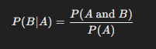

Here:

* P(B∣A) is the conditional probability of B given A.
* P(A and B) is the probability of both A and B occurring.
* P(A) is the probability of A occurring.

### Key Points

* The formula assumes P(A)≠0, meaning event A has a non-zero probability of occurring.
* Conditional probability can be thought of as the probability of B occurring in the "reduced" sample space where A has already occurred.

### Example

Suppose you have a deck of 52 cards, and you draw one card. Let event A be the event that the card drawn is a Spade, and event B be the event that the card drawn is an Ace.

We want to find the conditional probability that the card is an Ace given that it is a Spade.

* P(A)=13/52=1/4​ (since there are 13 Spades in a deck of 52 cards).
* P(A and B)=1/52P​ (since there is exactly one card that is both a Spade and an Ace—the Ace of Spades).

Using the formula for conditional probability:



So, the probability that the card is an Ace given that it is a Spade is 1/13​.

### Summary

* **Conditional Probability**: The probability of one event occurring given that another event has already occurred.
* **Application**: Used in various fields like statistics, machine learning, and everyday decision-making where the probability of events changes based on new information.

Conditional probability is essential for understanding dependent events and is a building block for more advanced topics like Bayes' theorem.

**Random Variables:**

A **random variable** is a variable that takes on different numerical values based on the outcome of a random phenomenon or experiment. It is a function that assigns a numerical value to each possible outcome in a sample space of a random experiment.

**Types of Random Variables**

1. **Discrete Random Variables**:
   * A discrete random variable takes on a countable number of distinct values. These values are often integers or whole numbers.
   * **Example**: The number of heads obtained when flipping three coins. Possible values are 0, 1, 2, or 3.
2. **Continuous Random Variables**:
   * A continuous random variable takes on an infinite number of possible values within a given range. These values are typically measured rather than counted.
   * **Example**: The height of students in a class. The height can take any value within a continuous range.

**Probability Distribution**

* **Discrete Probability Distribution**: For a discrete random variable, the probability distribution is a list of the probabilities associated with each of its possible values.
  + **Example**: If X is the number of heads in two coin flips, X can take values 0, 1, or 2, with probabilities P(X=0), P(X=1), and P(X=2).
* **Continuous Probability Distribution**: For a continuous random variable, the probability distribution is described by a probability density function (PDF), where the probability of the variable taking a specific value is zero, and probabilities are instead assigned to intervals.
  + **Example**: The normal distribution, where the probability of a variable falling within a specific range can be calculated using the area under the curve.

**Expected Value (Mean)**

The expected value (or mean) of a random variable provides a measure of the "central" value or the average outcome. For a discrete random variable, it's calculated as:



For a continuous random variable, the expected value is calculated using an integral:



### Variance and Standard Deviation

* **Variance**: The variance of a random variable measures the spread or dispersion of the values it can take. It is calculated as the expected value of the squared deviation from the mean.



* **Standard Deviation**: The standard deviation is the square root of the variance and provides a measure of the average distance from the mean.



**Example: Discrete Random Variable**

Consider rolling a fair six-sided die. Let X be the random variable representing the number rolled. X can take values 1, 2, 3, 4, 5, or 6, each with a probability of 1/6​.

* The expected value E(X) would be:



**Summary**

* A random variable assigns numerical values to outcomes of a random phenomenon.
* Discrete random variables have countable outcomes, while continuous random variables have an infinite number of possible outcomes within a range.
* Probability distributions describe the likelihood of each outcome, and key metrics like expected value, variance, and standard deviation provide insights into the behavior of the random variable.

**Scaling and Shifting Random Variables**

Scaling and shifting random variables are operations that change the distribution and characteristics of those variables. Understanding how these operations affect key properties like the mean, variance, and standard deviation is crucial in probability and statistics.

### Scaling a Random Variable

**Scaling** a random variable involves multiplying it by a constant. If X is a random variable and a is a constant, the scaled random variable Y is defined as:

**Y = a * X**

#### **Impact on Mean and Variance:**

* **Mean**: The mean of the scaled random variable Y is scaled by the same factor aaa:

**E(Y) = E(aX) = a * E(X)**

* **Variance**: The variance of the scaled random variable is scaled by the square of the factor aaa:

**Var(Y) = Var(aX) = a2 * Var(X)**

* **Standard Deviation**: The standard deviation, which is the square root of the variance, is scaled by the absolute value of the factor a:

**SD(Y) = ∣a∣ * SD(X)**

### Shifting a Random Variable

**Shifting** a random variable involves adding or subtracting a constant from it. If X is a random variable and b is a constant, the shifted random variable Z is defined as:

**Z = X+b**

#### **Impact on Mean and Variance:**

* **Mean**: The mean of the shifted random variable Z is shifted by the constant b:

**E(Z) = E(X+b) = E(X) + b**

* **Variance**: The variance of the shifted random variable remains unchanged because variance measures the spread around the mean, not the location of the distribution:

**Var(Z) = Var(X)**

* **Standard Deviation**: Similarly, the standard deviation remains unchanged:

**SD(Z) = SD(X)**

**Combined Scaling and Shifting**

When a random variable is both scaled and shifted, the new random variable W is:

**W = a * X + b**

* **Mean**: The mean is affected by both the scaling and shifting:

**E(W) = a * E(X)+b**

* **Variance**: Only the scaling factor affects the variance:

**Var(W) = a2 * Var(X)**

* **Standard Deviation**: The standard deviation is scaled by ∣a∣:

**SD(W) = ∣a∣ × SD(X)**

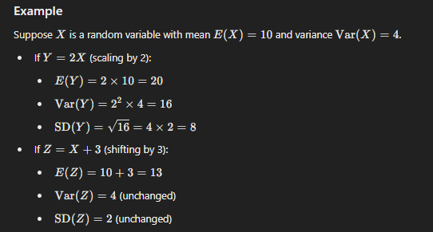

**Summary**

* **Scaling** affects both the mean and variance/standard deviation, with the mean scaling linearly and the variance scaling quadratically.
* **Shifting** affects only the mean, leaving the variance and standard deviation unchanged.
* These operations are important when transforming data or when applying operations in probability distributions and regression analysis.

**Combination of Random Variables**

Combining random variables is a common operation in probability and statistics, where you might add, subtract, or otherwise combine random variables to study their joint behavior. When combining random variables, we often focus on understanding the resulting mean, variance, and distribution.

### Addition of Random Variables

If X and Y are two random variables, the sum Z = X + Y is also a random variable.

#### **Mean of the Sum**

The expected value (mean) of the sum of two random variables is the sum of their means:

**E(Z) = E(X+Y) = E(X) + E(Y)**

#### **Variance of the Sum (Independent Random Variables)**

If X and Y are independent, the variance of their sum is the sum of their variances:

**Var(Z) = Var(X+Y) = Var(X) + Var(Y)**

**For the standard deviation of the sum:**

**SD(Z) = √Var(Z)**

#### **Variance of the Sum (Dependent Random Variables)**

If X and Y are not independent, their covariance Cov(X,Y) must be considered:

**Var(Z) = Var(X+Y) = Var(X) + Var(Y) + 2Cov(X,Y)**

### Subtraction of Random Variables

If Z = X − Y, the mean and variance are calculated similarly to addition, but with subtraction where appropriate.

#### **Mean of the Difference**

**E(Z) = E(X−Y) = E(X) − E(Y)**

#### **Variance of the Difference (Independent Random Variables)**

If X and Y are independent, the variance of their difference is still the sum of their variances (since variance is always positive):

**Var(Z) = Var(X−Y) = Var(X) + Var(Y)**

#### **Variance of the Difference (Dependent Random Variables)**

If X and Y are dependent, include the covariance term:

**Var(Z) = Var(X−Y) = Var(X) + Var(Y) − 2Cov(X,Y)**

### Example

Suppose X and Y are independent random variables with the following properties:

* E(X) = 5, Var(X) = 4
* E(Y) = 3, Var(Y) = 2

For the sum Z = X + Y:

* Mean: E(Z) = 5 + 3 = 8
* Variance: Var(Z) = 4 + 2 = 6
* Standard Deviation: SD(Z) = √6

For the difference W = X – Y:

* Mean: E(W) = 5 – 3 = 2
* Variance: Var(W) = 4 + 2 = 6
* Standard Deviation: SD(W) = √6

### Linear Combination of Random Variables

For a linear combination of random variables W = a X + b Y, where a and b are constants:

* Mean:

**E(W) = a * E(X) + b * E(Y)**

* Variance (if X and Y are independent):

**Var(W) = a2 * Var(X) + b2 * Var(Y)**

### Summary

* **Addition/Subtraction**: The mean of the sum/difference is the sum/difference of the means, and the variance is the sum of the variances (plus or minus the covariance if dependent).
* **Linear Combination**: The mean and variance are adjusted by the coefficients of the random variables.
* **Independence vs. Dependence**: Variance calculations differ depending on whether the random variables are independent or dependent. Covariance plays a role in dependent scenarios.

**Binomial Variables:**

**Binomial Variables** refer to random variables that arise from binomial experiments or trials. A binomial experiment is one that meets the following criteria:

1. **Fixed Number of Trials**: The experiment is repeated a fixed number of times.
2. **Two Possible Outcomes**: Each trial has exactly two possible outcomes, often labeled as "success" and "failure."
3. **Constant Probability**: The probability of success remains the same for each trial.
4. **Independence**: Each trial is independent of the others, meaning the outcome of one trial does not affect the outcome of another.

**Characteristics of a Binomial Variable**

A binomial random variable X represents the number of successes in n independent trials, each with a probability of success p. The variable X can take any integer value from 0 to n.

* **Notation**: X∼Binomial(n,p), where n is the number of trials and p is the probability of success.
* **Support**: X can take values 0,1,2,…,n.

### Probability Mass Function (PMF)

The probability of observing exactly k successes in n trials is given by the binomial probability mass function (PMF):

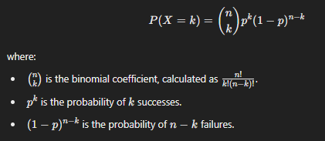

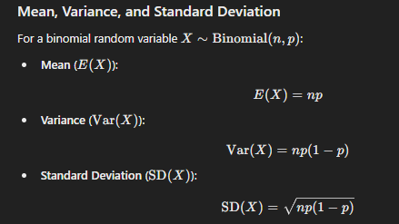

**Example**

Suppose you flip a fair coin 10 times, and you are interested in the number of heads. Here:

* N = 10 (number of trials)
* P = 0.5 (probability of heads, or success)

Let X be the random variable representing the number of heads. Then X∼Binomial(10,0.5).

* **Mean**:

E(X) = 10 × 0.5 = 5

* **Variance**:

Var(X) = 10 × 0.5 × (1−0.5)=2.5

* **Standard Deviation**:

SD(X) = √2.5 ≈ 1.58

* **Probability of getting exactly 6 heads**:



**Applications of Binomial Variables**

Binomial variables are used in scenarios where you are counting the number of successes in a series of identical trials. Some common applications include:

* Quality control (e.g., counting the number of defective products in a batch)
* Survey results (e.g., number of people who respond "yes" to a question)
* Medical trials (e.g., number of patients who experience side effects)

**Summary**

* **Binomial Variables** arise from binomial experiments with fixed trials, two outcomes, constant probability, and independence.
* They have well-defined mean, variance, and standard deviation.
* The probability of any given number of successes can be calculated using the binomial PMF.

**10% Rule**

The **10% Rule** is a guideline used in statistics to determine when it's reasonable to assume that trials are independent, even when sampling without replacement from a finite population.

**Understanding the 10% Rule**

* **Independence in Probability**: In probability theory, trials are considered independent if the outcome of one trial does not affect the outcome of another. However, when sampling without replacement (e.g., drawing cards from a deck without putting them back), the independence assumption is technically violated, because the composition of the remaining population changes after each draw.
* **10% Rule**: The 10% Rule states that if the sample size n is less than or equal to 10% of the population size N, the trials can be treated as independent for practical purposes. This is because the change in probability is so small that it has a negligible effect on the results.

**Why the 10% Rule Works**

When sampling without replacement, the probability of selecting a particular item changes slightly with each draw. However, if you're sampling a small fraction of the population (less than 10%), the difference in probabilities between draws is minimal. This means that the effect of one trial on another is so small that assuming independence won't significantly distort the results.

**Example of the 10% Rule**

Suppose a factory produces 10,000 widgets, and you want to check 500 of them for defects. Since 500 is 5% of 10,000, which is less than 10%, you can reasonably assume that the trials (checking each widget) are independent, even though you're not replacing the widgets after checking.

**Application in Statistical Inference**

The 10% Rule is particularly important in:

* **Binomial Distributions**: When using a binomial model to approximate real-world situations, the 10% Rule helps justify the assumption of independence, even if sampling without replacement.
* **Confidence Intervals and Hypothesis Tests**: It ensures that the standard formulas for variance, standard error, and test statistics remain valid.

**Summary**

* The **10% Rule** allows us to assume independence between trials when sampling without replacement, as long as the sample size is 10% or less of the total population.
* This rule is a practical guideline that simplifies analysis and is especially useful when applying binomial distributions or conducting statistical inference on finite populations.

**Sampling Distributions**

**Sampling distributions** refer to the probability distributions of statistics obtained through repeated sampling from a population. They provide insight into how a statistic (like the sample mean, sample proportion, etc.) would behave if we were to take many samples from the population.

### Key Concepts of Sampling Distributions

1. **Population vs. Sample**:
   * **Population**: The entire group you're interested in studying.
   * **Sample**: A subset of the population used to make inferences about the entire population.
2. **Statistic**:
   * A numerical characteristic calculated from a sample, such as the sample mean, sample proportion​, or sample variance..
3. **Sampling Distribution**:
   * The distribution of a statistic over many samples drawn from the same population. For example, if you repeatedly draw samples of size n and calculate the sample mean each time, the sampling distribution of the sample mean is the distribution of those sample means.

### Examples of Common Sampling Distributions

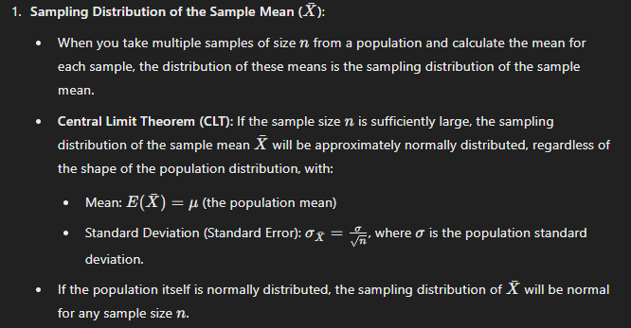

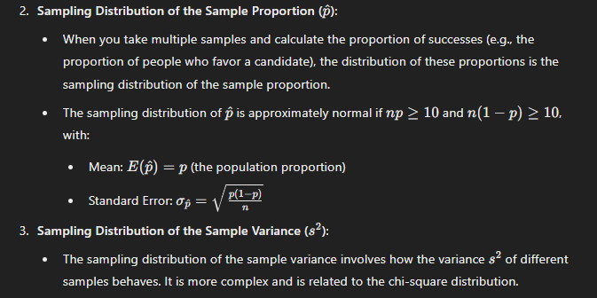

### Importance of Sampling Distributions

* **Inference**: Sampling distributions form the foundation of statistical inference, allowing us to make estimates (e.g., confidence intervals) and perform hypothesis tests about population parameters.
* **Standard Error**: The standard deviation of a sampling distribution, called the standard error, measures the variability of the statistic. Smaller standard errors indicate that the statistic is more reliable.
* **Normal Approximation**: Many sampling distributions can be approximated by a normal distribution, especially as sample size increases, thanks to the Central Limit Theorem.

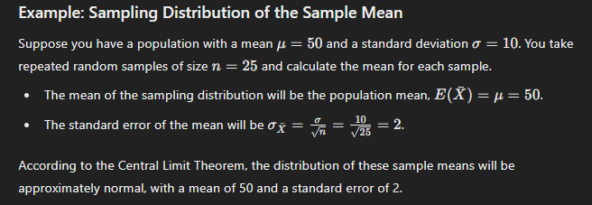

### Summary

* **Sampling Distributions** describe the behavior of sample statistics over repeated sampling from the population.
* They allow us to understand the variability of statistics and make inferences about population parameters.
* Key concepts like the Central Limit Theorem play a critical role in making normal approximations of sampling distributions, especially for large sample sizes.

**Geometric Random Variable**

A **geometric random variable** is a type of discrete random variable that counts the number of trials required to achieve the first success in a sequence of independent Bernoulli trials (trials with only two possible outcomes: success or failure). The key characteristics of a geometric random variable include a constant probability of success p on each trial and the fact that trials are independent of each other.

### Characteristics of a Geometric Random Variable

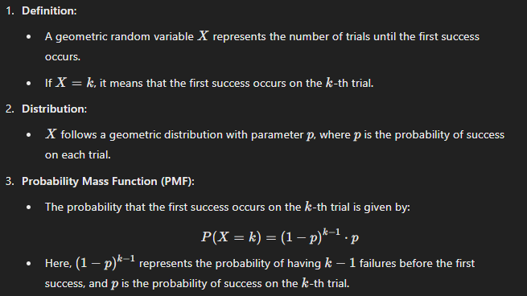

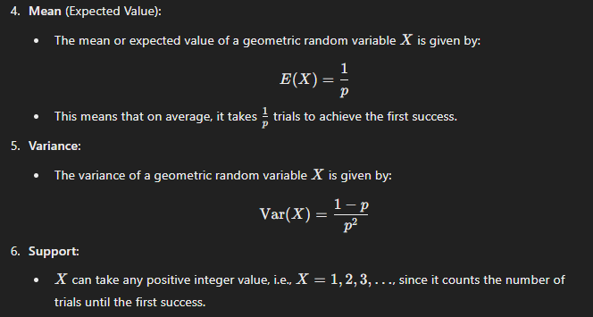

### Example of a Geometric Random Variable

### 

### Applications of Geometric Random Variables

Geometric random variables are useful in scenarios where you are interested in the number of trials needed to achieve a single success, such as:

* Quality control (e.g., how many products need to be inspected before finding a defective one).
* Marketing (e.g., how many calls a salesperson needs to make before securing a sale).
* Gambling (e.g., how many rolls of a die until a specific number is rolled).

**Confidence Intervals**

**Confidence intervals** are a range of values, derived from a sample, that are used to estimate an unknown population parameter (such as the mean or proportion). The interval has an associated confidence level that quantifies the level of confidence that the parameter lies within the interval.

### Key Concepts of Confidence Intervals

1. **Confidence Level**:
   * The confidence level, usually expressed as a percentage (e.g., 90%, 95%, 99%), indicates the degree of certainty that the population parameter lies within the confidence interval.
   * A 95% confidence level means that if we were to take many random samples and construct a confidence interval from each, approximately 95% of these intervals would contain the true population parameter.
2. **Margin of Error**:
   * The margin of error is the amount added and subtracted from the sample estimate (e.g., the sample mean) to create the confidence interval. It reflects the level of uncertainty associated with the estimate.
   * It depends on the confidence level and the variability in the data (as measured by the standard deviation or standard error).

### Interpretation of Confidence Intervals

* **Correct Interpretation**: "We are 95% confident that the true population mean height lies within the interval [173.016, 176.984] cm."
* **Incorrect Interpretation**: "There is a 95% probability that the true mean is within this interval." (The true mean is fixed, and the interval either contains it or does not.)

### Summary

* **Confidence intervals** provide a range of plausible values for a population parameter, with an associated confidence level indicating the reliability of the estimate.
* They are constructed using the sample statistic, the margin of error, and a critical value corresponding to the desired confidence level.
* Confidence intervals are widely used in statistics to estimate population parameters and to convey the uncertainty associated with sample estimates.

**Estimating Population Proportion Using Confidence Intervals**

Estimating a population proportion involves using sample data to estimate the true proportion of a population that possesses a particular characteristic. This is commonly done by constructing a confidence interval for the population proportion.

### Steps to Estimate a Population Proportion

### 

### 

### Example of Estimating a Population Proportion

Suppose you conducted a survey of 500 people to find out how many of them prefer a certain brand of product. Out of the 500 respondents, 200 said they prefer the brand. You want to estimate the population proportion who prefer the brand with a 95% confidence interval.

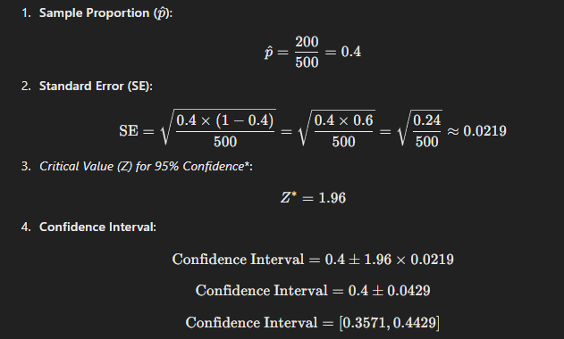

### Interpretation

* The 95% confidence interval for the population proportion is [0.3571,0.4429].
* This means you can be 95% confident that the true proportion of the population who prefer the brand is between 35.71% and 44.29%.

### Summary

* **Estimating a population proportion** involves using a sample proportion to infer about the entire population.
* The **confidence interval** gives a range where the true population proportion is likely to be found, based on the sample data and desired confidence level.
* This method is crucial in various fields like market research, polling, and quality control, where making inferences about a population based on a sample is common.

**Estimating Population Mean Using Confidence Intervals**

Estimating a population mean involves using sample data to estimate the true mean (average) of a population. This is commonly done by constructing a confidence interval for the population mean.

### Steps to Estimate a Population Mean

### 

### 

### Example of Estimating a Population Mean

Suppose you want to estimate the average weight of apples in an orchard. You take a random sample of 50 apples and find that the average weight is 150 grams with a standard deviation of 15 grams. You want to construct a 95% confidence interval for the population mean weight.

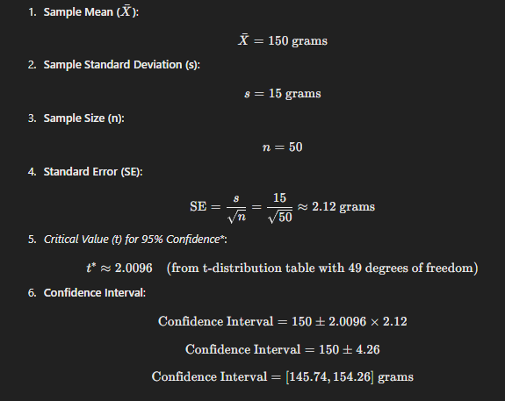

### Interpretation

* The 95% confidence interval for the population mean weight of apples is [145.74,154.26] grams.
* This means you can be 95% confident that the true average weight of all apples in the orchard lies within this interval.

### Summary

* **Estimating a population mean** involves using the sample mean to make inferences about the population mean.
* The **confidence interval** gives a range where the true population mean is likely to be found, based on the sample data and desired confidence level.
* The use of the t-distribution is particularly important when the sample size is small and the population standard deviation is unknown.

When estimating a population mean or proportion, the choice between using a **z-interval** or a **t-interval** depends on specific conditions. Here’s a summary of the conditions under which each interval is valid:

### Conditions for a Valid Z-Interval

A z-interval is typically used for estimating a population proportion or mean when certain conditions are met:

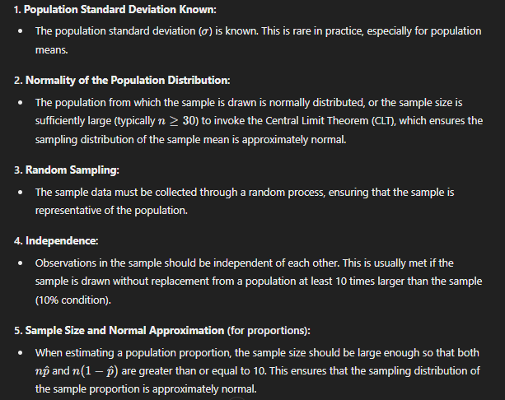

### Conditions for a Valid T-Interval

A t-interval is used when estimating a population mean, particularly when the population standard deviation is unknown and the sample size is relatively small.

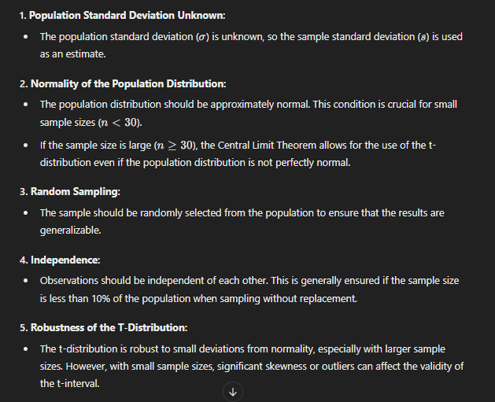

### Summary

* **Use a Z-Interval** when:
  + The population standard deviation is known.
  + The sample size is large (n ≥ 30) or the population is normally distributed.
  + The data is collected randomly, and observations are independent.
* **Use a T-Interval** when:
  + The population standard deviation is unknown.
  + The population distribution is normal, especially with small sample sizes (n<30).
  + The data is collected randomly, and observations are independent.

Choosing the correct interval depends on meeting these conditions, which ensures that the resulting confidence interval is reliable and accurate.

**Hypothesis Testing**

**Hypothesis testing** is a statistical method used to make decisions or inferences about a population parameter based on sample data. It involves setting up two competing hypotheses, collecting data, and then using a test statistic to determine which hypothesis is more supported by the data.

### Key Components of Hypothesis Testing

### 

### 

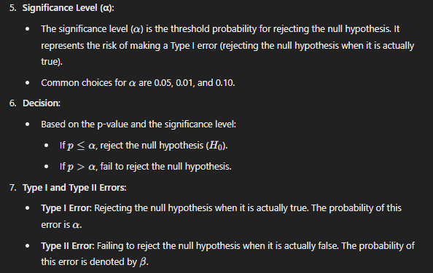

**Steps in Hypothesis Testing**

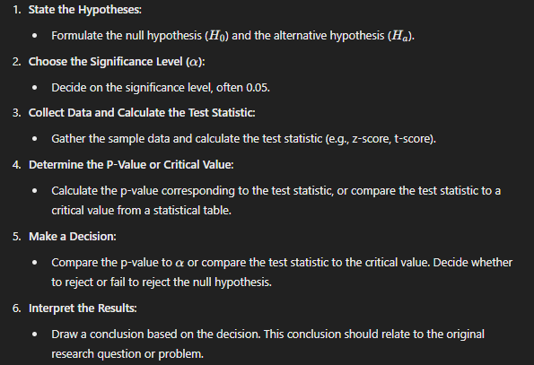

### Example of Hypothesis Testing

**Scenario**: A factory claims that the average weight of its product is 100 grams. A quality control team wants to test if this claim is accurate.

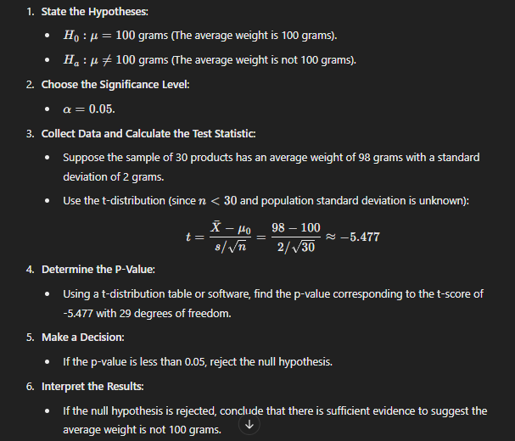

### Summary

* **Hypothesis testing** is a fundamental tool for making inferences about populations using sample data.
* It involves comparing observed data to what is expected under the null hypothesis and making decisions based on the calculated p-value or test statistic.
* Understanding the process and conditions for valid testing ensures reliable conclusions.

**Types of Hypothesis Testing**

There are several types of hypothesis testing methods, each suited to different types of data and research questions. The choice of hypothesis test depends on the nature of the data, the research question, and the assumptions that can be made about the population from which the sample is drawn. Below are the main types of hypothesis testing:

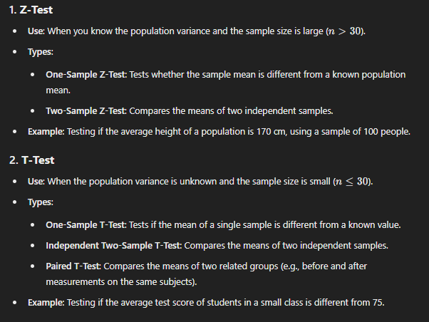

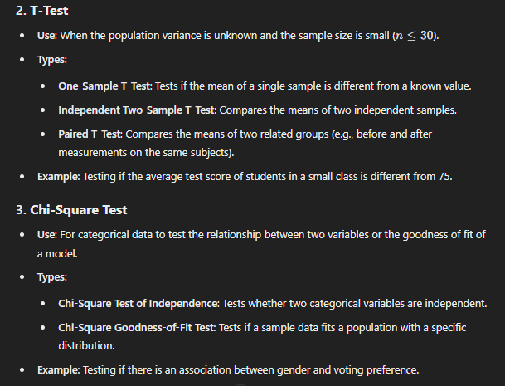

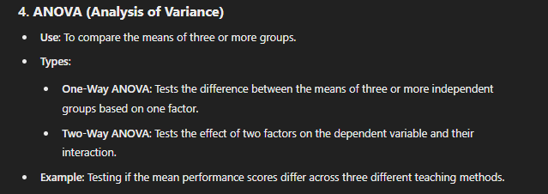

**Z-Test Example:**

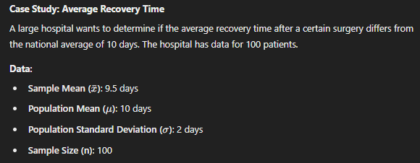

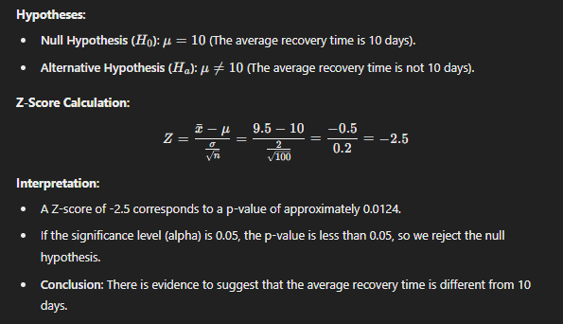

**Z-Test for Proportions Example**

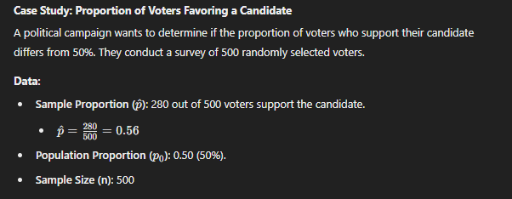

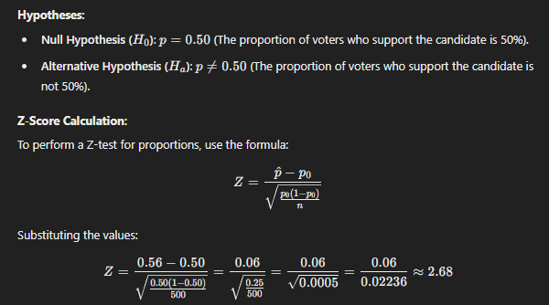

#### **Interpretation**:

* A Z-score of 2.68 corresponds to a p-value of approximately 0.0074 (using a Z-table or standard normal distribution).
* If the significance level (alpha) is 0.05, the p-value (0.0074) is less than 0.05.
* **Conclusion**: Since the p-value is less than 0.05, we reject the null hypothesis. There is significant evidence to suggest that the proportion of voters who support the candidate is different from 50%.

This example shows how to use a Z-test to determine if the observed proportion in a sample is significantly different from a hypothesized population proportion.

**T-Test Example**

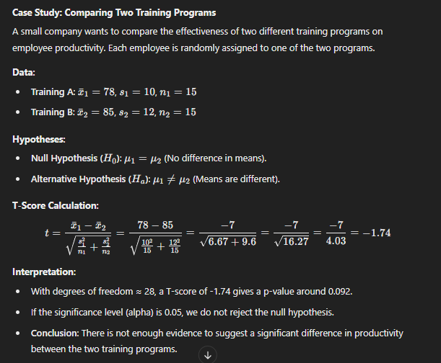

**Chi-Square Test**

### ****Purpose****

* To determine whether there is a significant association between two categorical variables.
* It assesses whether the distribution of sample categorical data matches an expected distribution when the variables are independent.

### ****Assumptions****

* The data are frequencies (counts) of cases in each category.
* Observations are independent of each other.
* The expected frequency in each cell of the table should be at least 5 for the approximation to be valid (some sources accept expected frequencies as low as 1 if the total sample size is large enough).

### Chi-Square Test for Independence

### ****Example Case Study****

|  |  |  |  |
| --- | --- | --- | --- |
|  | **Prefers Product** | **Does Not Prefer Product** | **Total** |
| **Male** | 60 | 40 | 100 |
| **Female** | 30 | 70 | 100 |
| **Total** | 90 | 110 | 200 |

**Scenario**: A researcher wants to investigate whether there is an association between gender and preference for a new product. A survey is conducted among 200 individuals.

**DATA COLLECTED**

### ****Step-by-Step Calculation****



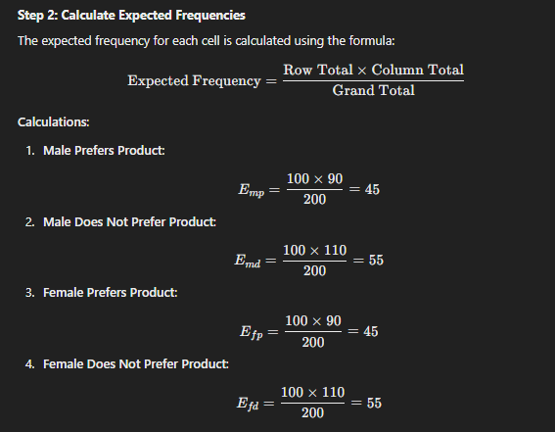

**Expected Frequency Table**:

|  |  |  |  |
| --- | --- | --- | --- |
|  | **Prefers Product** | **Does Not Prefer Product** | **Total** |
| **Male** | 45 | 55 | 100 |
| **Female** | 45 | 55 | 100 |
| **Total** | 90 | 110 | 200 |

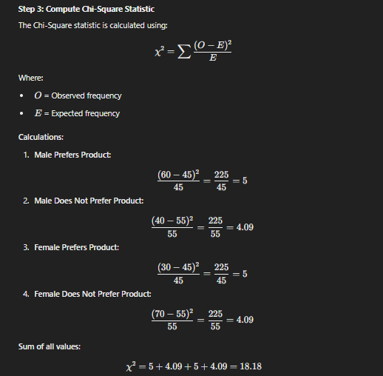

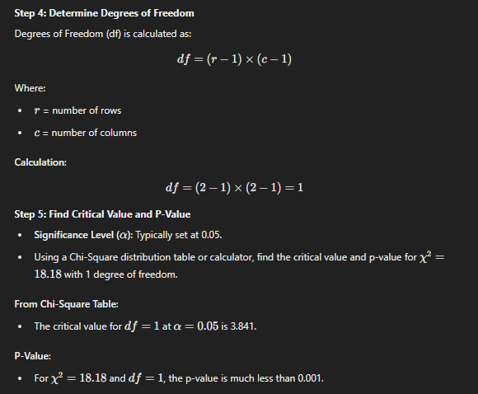

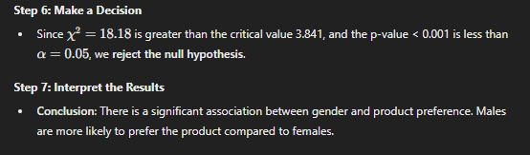

**Chi-Square Goodness-of-Fit Test**

### ****Purpose****

* To determine whether the observed frequency distribution of a categorical variable matches an expected distribution.

### ****Assumptions****

* The data are frequencies (counts).
* Observations are independent.
* Expected frequencies for each category should be at least 5.

### ****Example Case Study****

**Scenario**: A dice manufacturer claims that their dice are fair. To test this claim, you roll a die 120 times and record the frequency of each outcome.

### ****Data Collected****

|  |  |
| --- | --- |
| **Die Face** | **Observed Frequency (O)** |
| 1 | 15 |
| 2 | 20 |
| 3 | 18 |
| 4 | 22 |
| 5 | 25 |
| 6 | 20 |
| **Total** | 120 |

### ****Step-by-Step Calculation****

### 

**Expected Frequency Table**:

|  |  |
| --- | --- |
| **Die Face** | **Expected Frequency (E)** |
| 1 | 20 |
| 2 | 20 |
| 3 | 20 |
| 4 | 20 |
| 5 | 20 |
| 6 | 20 |
| **Total** | 120 |

### 

### 

### 

## **Summary**

**Chi-Square Test for Independence**:

* Used to determine if there is an association between two categorical variables.
* Compares observed frequencies in a contingency table to expected frequencies assuming independence.
* Requires calculation of expected frequencies, Chi-Square statistic, degrees of freedom, and p-value for decision-making.

**Chi-Square Goodness-of-Fit Test**:

* Used to assess whether observed frequencies match expected frequencies for a single categorical variable.
* Compares observed data to expected data under a specific distribution.
* Involves calculating Chi-Square statistic based on deviations between observed and expected frequencies, determining degrees of freedom, and interpreting p-values.

**Important Considerations**:

* Ensure sample size is adequate; expected frequencies should generally be at least 5.
* Observations should be independent.
* For small sample sizes or expected frequencies less than 5, consider using Fisher's Exact Test or combining categories where appropriate.

**Applications**:

* **Independence Test**: Market research (product preference vs. demographic variables), medical studies (disease occurrence vs. lifestyle factors).
* **Goodness-of-Fit Test**: Quality control (checking uniformity in production), genetics (observed vs. expected genotype frequencies).

**Anova:**

ANOVA, which stands for Analysis of Variance, is a statistical technique used to compare means across multiple groups. Here's a concise explanation:

1. Purpose: ANOVA tests whether there are statistically significant differences between the means of three or more independent groups.
2. Types:
   * One-way ANOVA: Compares means across one factor
   * Two-way ANOVA: Examines the influence of two factors
   * MANOVA: Multivariate analysis of variance for multiple dependent variables
3. Key concepts:
   * Null hypothesis: Assumes all group means are equal
   * F-statistic: Measures the ratio of between-group variance to within-group variance
   * p-value: Indicates the probability of obtaining the observed results if the null hypothesis is true
4. Assumptions:
   * Independence of observations
   * Normal distribution of residuals
   * Homogeneity of variances
5. Outcome: If the p-value is below the significance level (often 0.05), we reject the null hypothesis, concluding that at least one group mean differs significantly from the others.

**Example**:

Let's say a researcher wants to determine if three different study methods affect test scores differently. The study methods are:

1. Flashcards
2. Practice tests
3. Group discussions

The researcher randomly assigns 30 students to one of these three groups (10 students per group). After a week of using their assigned study method, all students take the same test. Here are the test scores (out of 100):

* Flashcards: 82, 79, 85, 90, 74, 83, 87, 81, 88, 86
* Practice tests: 89, 93, 87, 92, 85, 90, 88, 91, 94, 86
* Group discussions: 76, 80, 82, 84, 79, 83, 81, 77, 85, 78

The researcher wants to know if there's a significant difference in test scores based on the study method used.

Here's how ANOVA would be applied:

1. Set up hypotheses:
   * Null hypothesis (H0): There's no significant difference in mean test scores among the three study methods.
   * Alternative hypothesis (H1): At least one study method leads to significantly different mean test scores.
2. Calculate group means:
   * Flashcards: 83.5
   * Practice tests: 89.5
   * Group discussions: 80.5
3. Perform ANOVA calculations:
   * Calculate the total sum of squares (SST)
   * Calculate the between-group sum of squares (SSB)
   * Calculate the within-group sum of squares (SSW)
   * Compute the F-statistic
4. Interpret results: Let's say the analysis yields an F-statistic of 12.45 with a p-value of 0.0001.
5. Draw conclusions: Since the p-value (0.0001) is less than the typical significance level of 0.05, we reject the null hypothesis. This suggests that there is a statistically significant difference in test scores among the three study methods.
6. Post-hoc analysis: If the ANOVA reveals significant differences, the researcher might conduct post-hoc tests (like Tukey's HSD) to determine which specific groups differ from each other.

In this example, the results suggest that the choice of study method does impact test scores. The practice tests group seems to have performed best, followed by flashcards, and then group discussions. However, to confirm which differences are statistically significant, post-hoc tests would be necessary.

This example demonstrates how ANOVA can be used to compare means across multiple groups and determine if there are significant differences between them.

**Calculation**

Let's start with our data:

* Flashcards (F): 82, 79, 85, 90, 74, 83, 87, 81, 88, 86
* Practice tests (P): 89, 93, 87, 92, 85, 90, 88, 91, 94, 86
* Group discussions (G): 76, 80, 82, 84, 79, 83, 81, 77, 85, 78

**Step 1: Calculate group means and overall mean**

* F̄ = 835 / 10 = 83.5
* P̄ = 895 / 10 = 89.5
* Ḡ = 805 / 10 = 80.5

Overall mean (x̄) = (835 + 895 + 805) / 30 = 2535 / 30 = 84.5

**Step 2: Calculate Sum of Squares**

1. Total Sum of Squares (SST): SST = Σ(x - x̄)² for all observations SST = (82-84.5)² + (79-84.5)² + ... + (78-84.5)² = 1,646.5
2. Between-group Sum of Squares (SSB): SSB = Σ ni(x̄i - x̄)², where ni is the number of observations in each group SSB = 10(83.5-84.5)² + 10(89.5-84.5)² + 10(80.5-84.5)² = 450
3. Within-group Sum of Squares (SSW): SSW = SST - SSB = 1,646.5 - 450 = 1,196.5

**Step 3: Calculate degrees of freedom (df)**

* Total df: N - 1 = 30 - 1 = 29
* Between-group df: k - 1 = 3 - 1 = 2 (where k is the number of groups)
* Within-group df: N - k = 30 - 3 = 27

**Step 4: Calculate Mean Squares**

* Mean Square Between (MSB) = SSB / dfB = 450 / 2 = 225
* Mean Square Within (MSW) = SSW / dfW = 1,196.5 / 27 ≈ 44.31

**Step 5: Calculate F-statistic**

F = MSB / MSW = 225 / 44.31 ≈ 5.08

**Step 6: Determine critical F-value and p-value**

For α = 0.05, df1 = 2, df2 = 27, the critical F-value is approximately 3.35. The p-value for F = 5.08 with these degrees of freedom is approximately 0.0134.

**Step 7: Make a decision**

Since our calculated F (5.08) > critical F (3.35), and p-value (0.0134) < α (0.05), we reject the null hypothesis.

Conclusion: There is a statistically significant difference in test scores among the three study methods.